**Wi-Fi REPEATER USING ESP32**

**What you need:**

* An ESP32 board
* USB cable – USB A / micro USB B
* Computer running windows
* Toolchain to compile code for ESP32
* Build tools - CMake and Ninja to build a full Application for
* ESP32 ESP-IDF that essentially contains API (software libraries and source code) for ESP32 and scripts to operate the Toolchain
* Text editor to write programs (Projects) in C, e.g., Eclipse

See <https://docs.espressif.com/projects/esp-idf/en/latest/get-started/> for more details.

**Step 1:**

To set ESP32 as a Wi-Fi repeater we need to use the ESP-IDF (IoT Development Software) as the library needed is not ported to Arduino IDE. Get started with downloading the ESP-IDF:

<https://dl.espressif.com/dl/esp-idf-tools-setup-2.0.exe>

Use this link to download ESP-IDF Tools installer, once that has finished successfully the development environment setup is complete. You can now build and flash projects.



After the execution you should find this file on your desktop.

**Step 2:**

Now you must download the library needed for this project. This library supports NAT feature so is required for this project.

<https://github.com/jonask1337/esp-lwip>

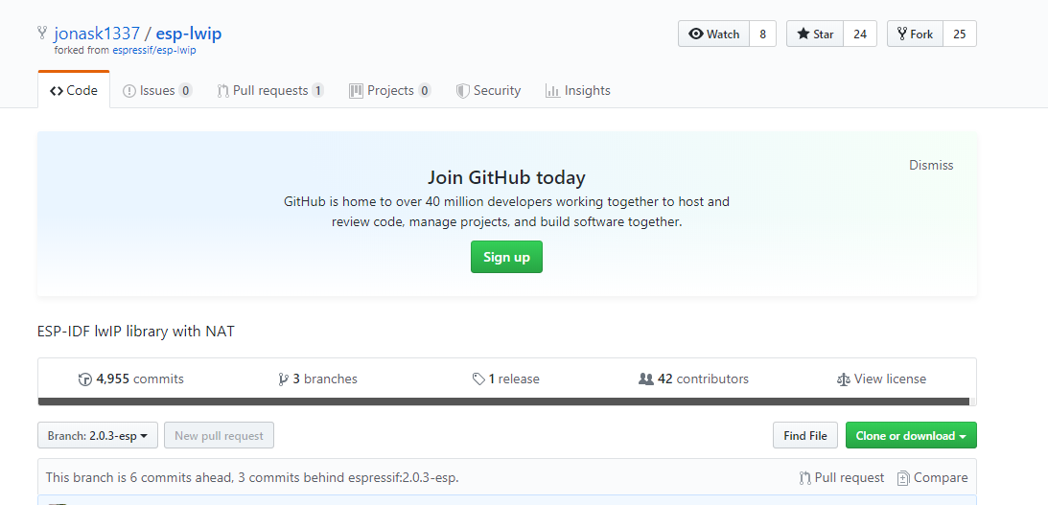

Click on ‘Clone or download’ and download ZIP.

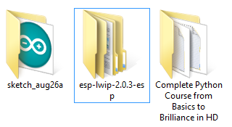

You should find above folder in your downloads after you extract from ZIP file.

The ‘esp-lwip-2.0.3-esp’ folder inside this ‘esp-lwip-2.0.3-esp’ folder needs to be placed inside the esp-idf folder.

Go to the esp-idf folder, then go to components.

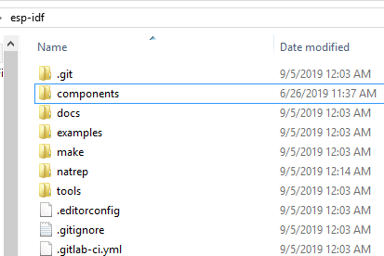

Inside components, click on lwip.

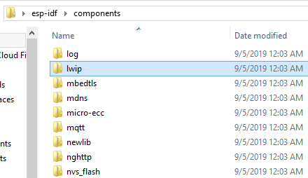

The lwip folder inside the lwip folder is the one that needs to be replaced.

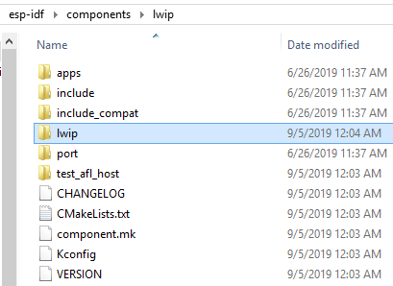

Rename the lwip folder to ‘lwip old’ and add the downloaded library to this folder.

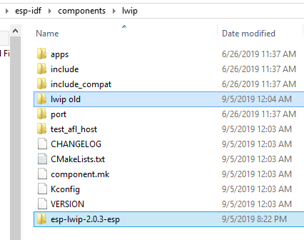

Rename ‘esp lwip 2.0.3-esp’ to ‘lwip’.

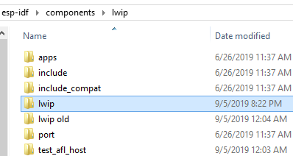

**Step 3:**

Now we can download the Wi-Fi repeater project and add it to the esp-idf directory.

<https://github.com/jonask1337/esp-idf-nat-example>

Just as before click on ‘Clone or download’ and download ZIP file.

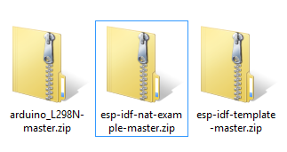

Extract the project from this file and copy it to the esp idf file, then rename it ‘natrep’.

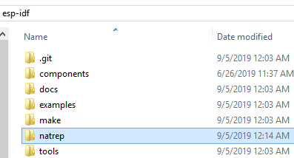

Open the ‘natrep’ folder and then open CMakeLists.txt, and change the project name to ‘natrep’.

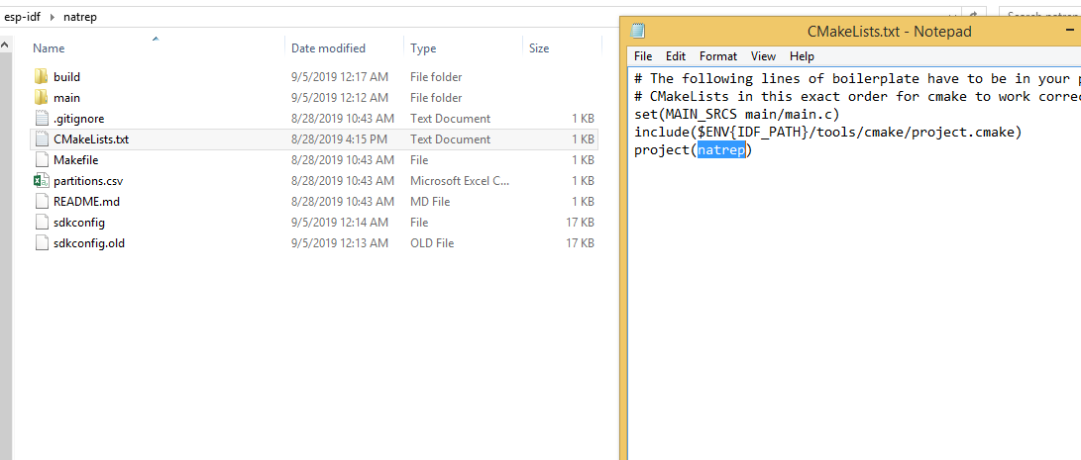

Save it and exit.

**Step 4:**

We need to now start the project and configure it.

Search for ESP-IDF Command Prompt. Go to the project directory and run the following command:

**cd natrep**

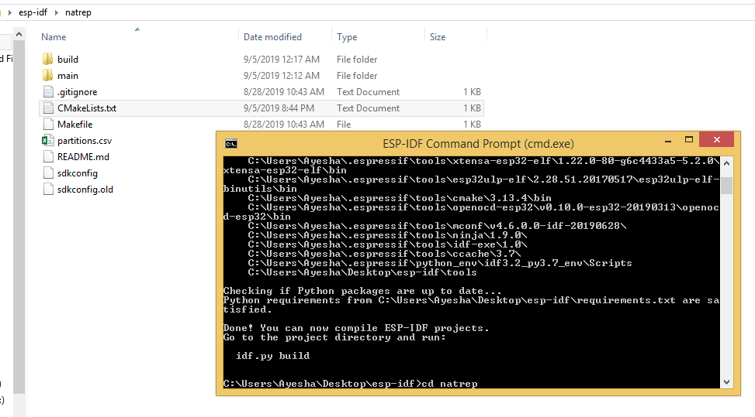

Now run the following command:

**idf.py menuconfig**

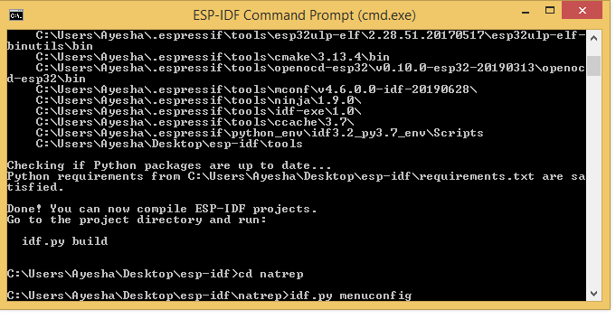

This will open the configuration menu, move down and select Component config:

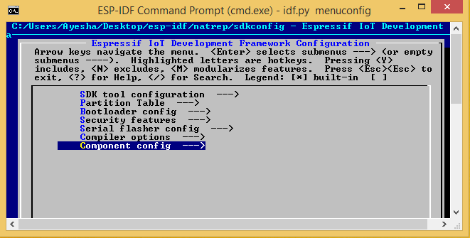

Now scroll down and select LWIP:

(P.S. This menu can only be operated using keyboard keys)

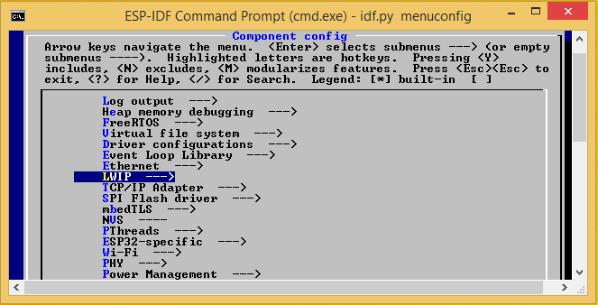

Use spacebar to turn on the following options:

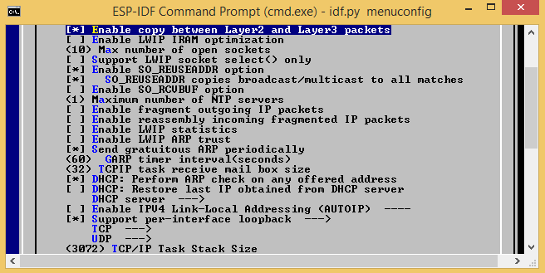

Scroll down and turn on:

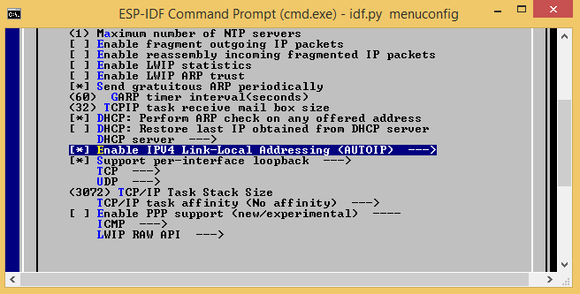

Now scroll all the way to the bottom and select ‘save’, the exit the menu:

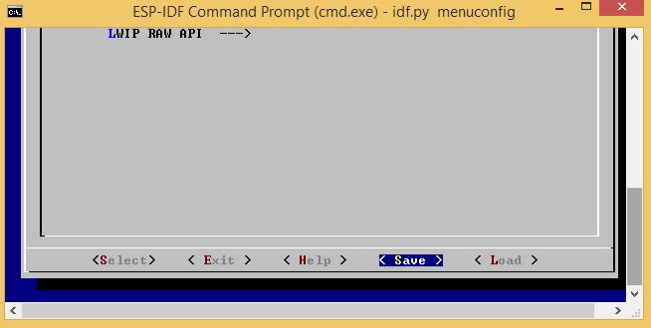

Keep selecting ‘exit’ till you leave the menu.

**Step 5:**

You need to now set your Wi-Fi name and passcode in the code. Navigate to the project folder: ‘natrep’. Go to main and open main.c on any text editor (eg. Notepad). Then edit the following areas with your WiFi name and passcode. Also, change the number of maximum tries to 30 from 3.

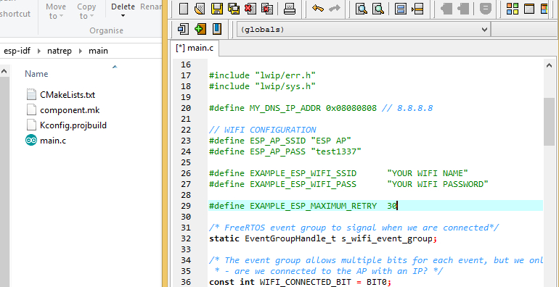

You can also change the name for your Wi-Fi repeater above. Save it and close.

**Step 6:**

You can now build your project by running the following command:

**idf.py build**

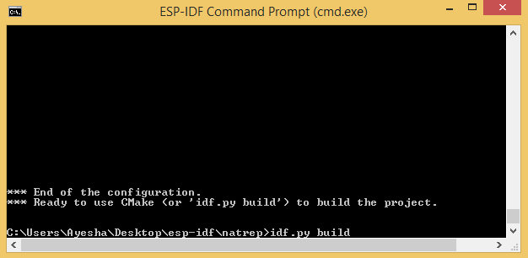

**Step 7:**

Final step: flashing the project onto ESP32 board using command

**idf.py –p COMx –b 115200 flash:** where x is the port number (4 in my case) and can be found by searching Device Manager in the start menu and clicking on ports.

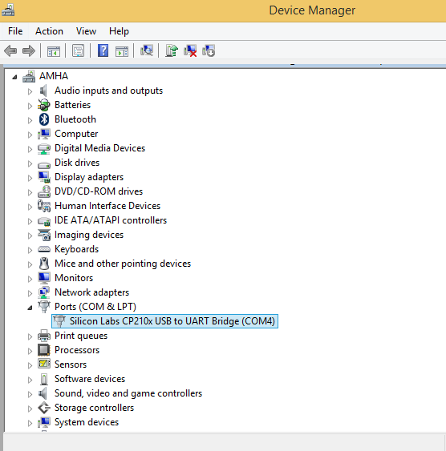

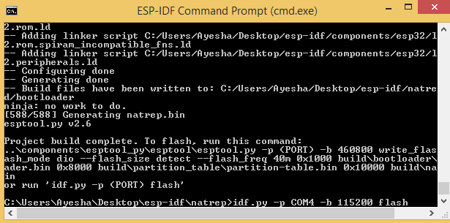

**BEFORE PRESSING ENTER PRESS BOOT ON ESP32 BOARD AND HOLD IT DOWN TILL FLASHING IS OVER.**

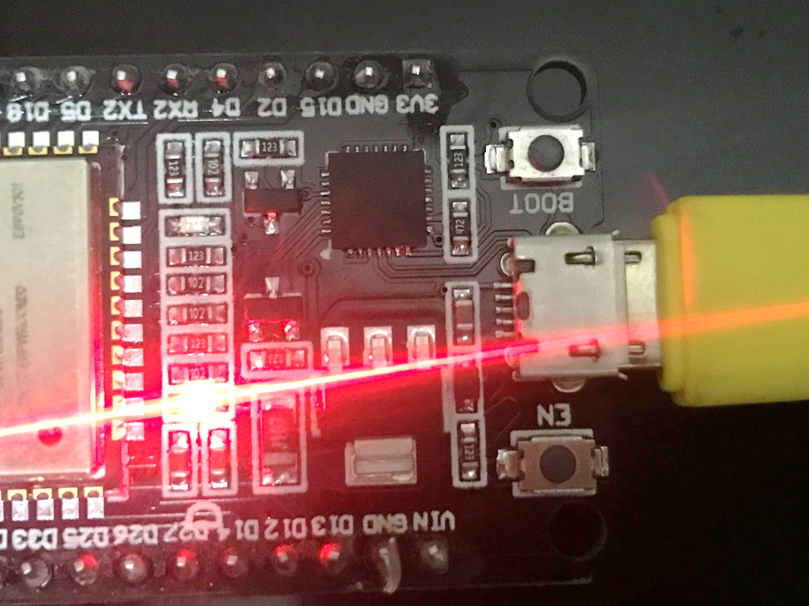

**Step 8:**

This step is optional but will help you check if your board has connected to your internet.

Download Arduino IDE: <https://www.arduino.cc/en/main/software>

Add ESP32 board as follows:

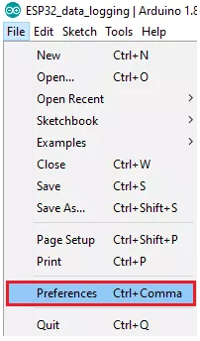

Enter <https://dl.espressif.com/dl/package_esp32_index.json> **to Additional Boards URLs**

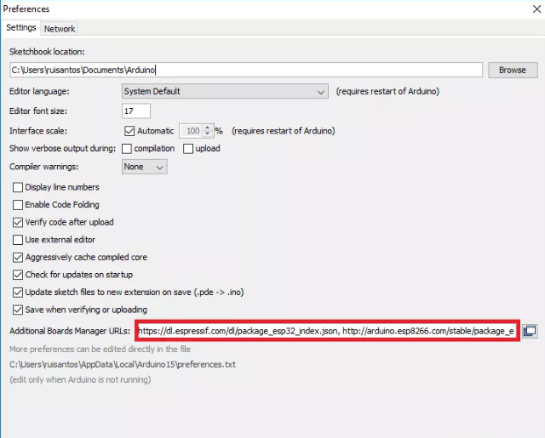

Now install the board as such:

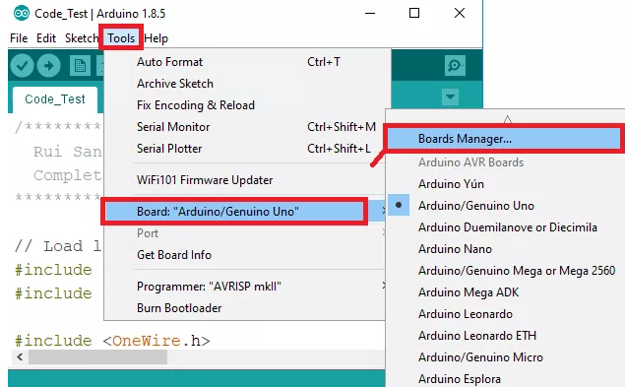

Search for ESP32:

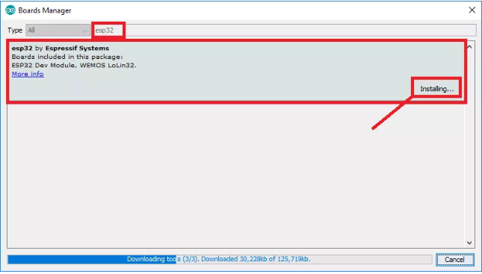

Once board is installed, press enable (EN) on board:



Open Serial Monitor and set baud rate 115200 and check if it’s connected to SSID:

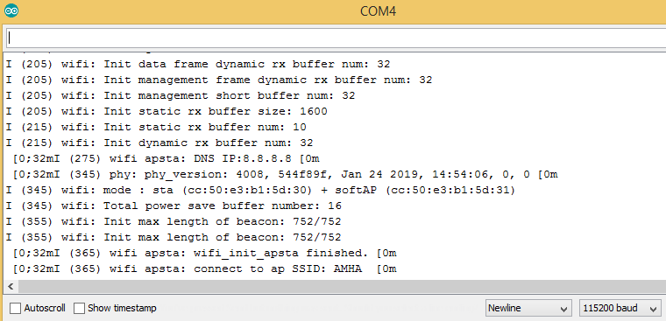

Done! Now you can use the ESP32 with a power bank, set if far away and increase your Wi-Fi range.